

**ΠΑΝΕΠΙΣΤΗΜΙΟ ΑΙΓΑΙΟΥ  
ΣΧΟΛΗ ΚΟΙΝΩΝΙΚΩΝ ΕΠΙΣΤΗΜΩΝ  
ΤΜΗΜΑ ΚΟΙΝΩΝΙΟΛΟΓΙΑΣ**

**THE CONDITIONS OF DETENTION IN PRISON KORYDALLOU**

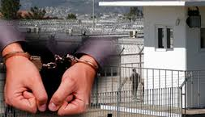

ΟΝΟΜΑ ΦΟΙΤΗΤΡΙΑΣ: KORAKA PANAGIOTA

**SUMMARY OF THE WORK**

Through this work we try to show the dire conditions in one of the largest custodians of our country.Overpopulation mistreatment lack of medical care are some problems faced daily by inmates of this penitentiary. What happens though with the regulations that are either our country or the European Union ?

For all the prisons in our country has adopted an internal regulation, which consists of 64 articles that define the responsibilities and nuances of the penitentiary, prisoners' rights and how the behavior of guards to prisoners. Those countries belonging to the European Union are obliged to follow the European regulation which defines torture in prisons there special treatment in women and children there are special places for pregnant women and infants. This situation must be changed but can be prisoners but also have rights which can not deprive them and their cracking 'the lawman. "